# Top, Middle, and Bottom Thirds

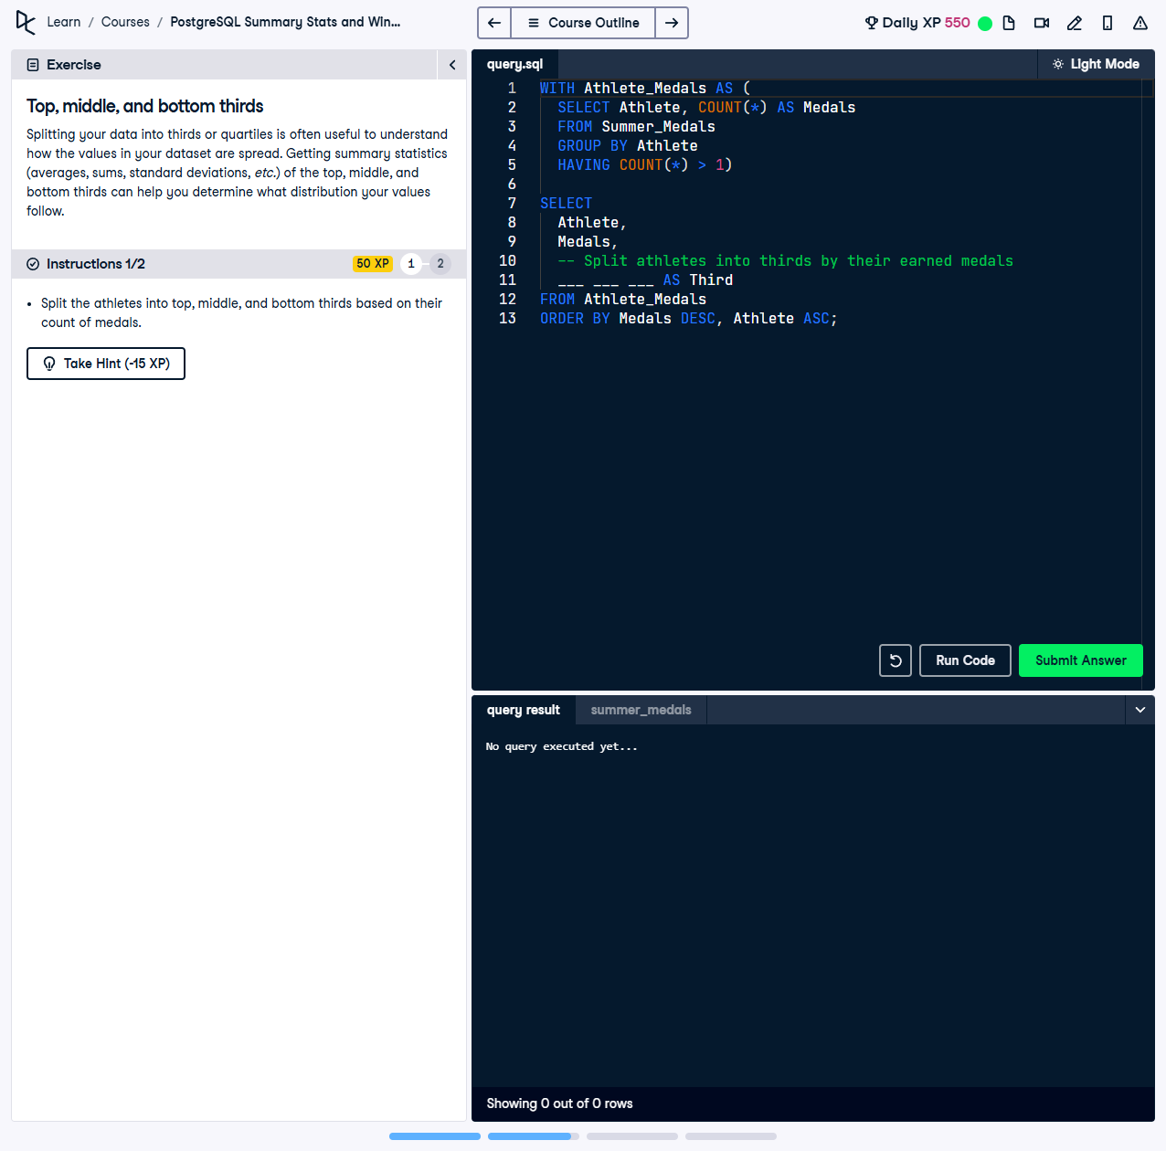

Splitting your data into thirds or quartiles is useful to understand how the values in your dataset are spread. Getting summary statistics (averages, sums, standard deviations, etc.) of the top, middle, and bottom thirds can help you determine what distribution your values follow.

This exercise involves using the `NTILE` function to divide athletes into three equal groups based on their total medal count, providing insights into their distribution across top, middle, and bottom performance tiers.

## Correct Answer

SELECT  
 Athlete,  
 COUNT(*) AS Medals,  
 NTILE(3) OVER (ORDER BY COUNT(*) DESC) AS Third  
FROM Summer_Medals  
GROUP BY Athlete  
HAVING COUNT(*) > 1;

Explanation of the query:

1. `COUNT(*) AS Medals`: Counts the total number of medals won by each athlete.

2. `NTILE(3) OVER (ORDER BY COUNT(*) DESC) AS Third`: Divides the athletes into three equal groups (top, middle, and bottom thirds) based on their medal count, with the highest medal counts in the first third.

3. `GROUP BY Athlete`: Ensures the counts are aggregated for each athlete.

4. `HAVING COUNT(*) > 1`: Filters the results to include only athletes with more than one medal.